**Lesson 95 – 105:**

Traditional Neural Networks doesn’t have memory function. ***Recurrent Neural Networks (RNN)*** are Neural Networks that have memory. Basically, when a Neuron process the information of the output, besides it send this to the output, it send this to the neuron again in a loop.

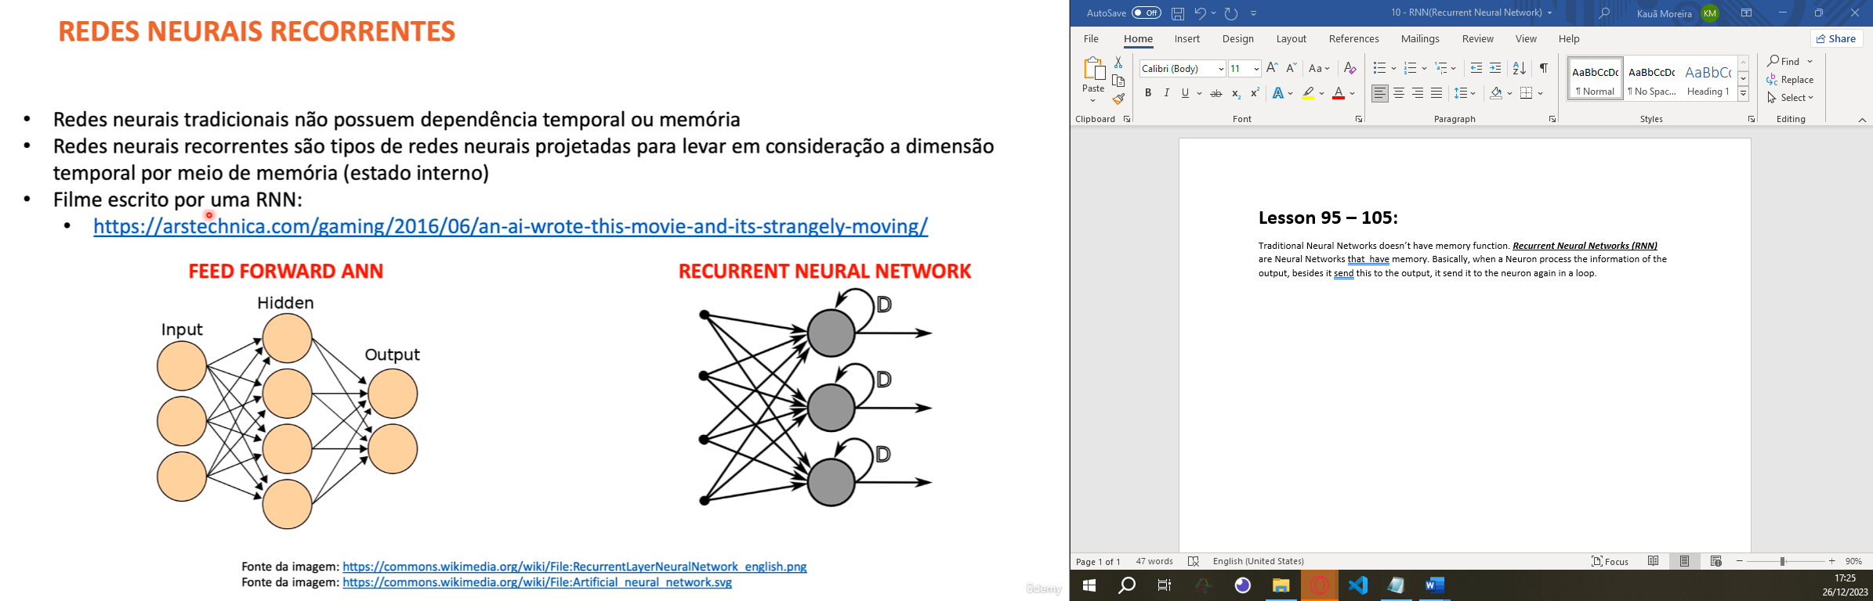

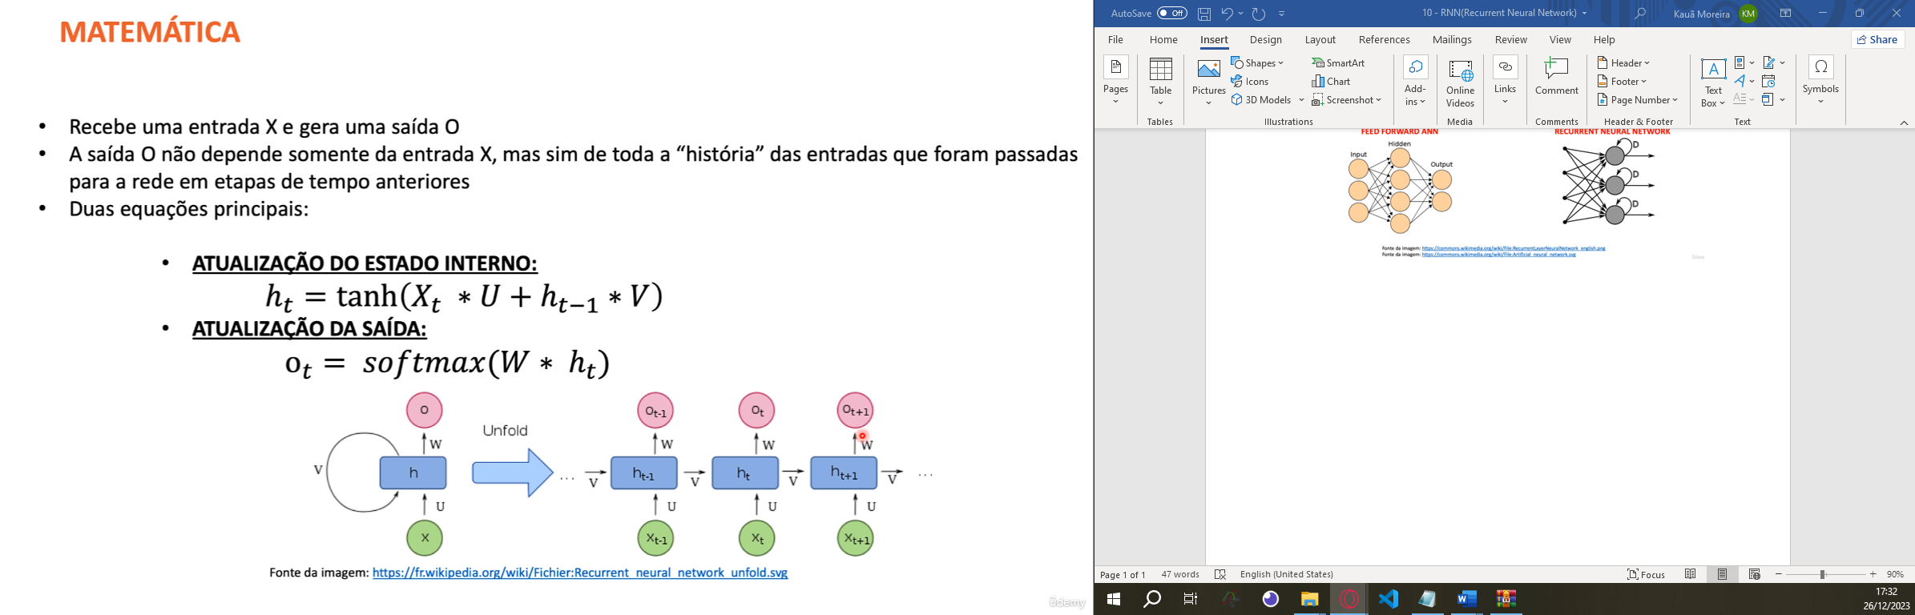

There are a lot of RNN architectures:

1. One-to-One: This architecture is not recurrent; it's the standard feedforward neural network, where one input is mapped to one output. It's not specific to RNNs and doesn't involve sequences.
2. Many-to-One: In this architecture, multiple inputs (a sequence) are fed into the RNN, and the network produces a single output or prediction. For instance, sentiment analysis of a text sequence (many words) to predict sentiment (positive/negative) is a many-to-one RNN.
3. One-to-Many: Here, a single input is used to generate multiple outputs or a sequence of outputs. For instance, generating a sentence caption for an image (single input) produces multiple words (sequence output).
4. Many-to-Many (same length): This architecture takes a sequence as input and generates a sequence of the same length as the output. For instance, translating a sentence from one language to another, where each word in the input corresponds to a word in the output.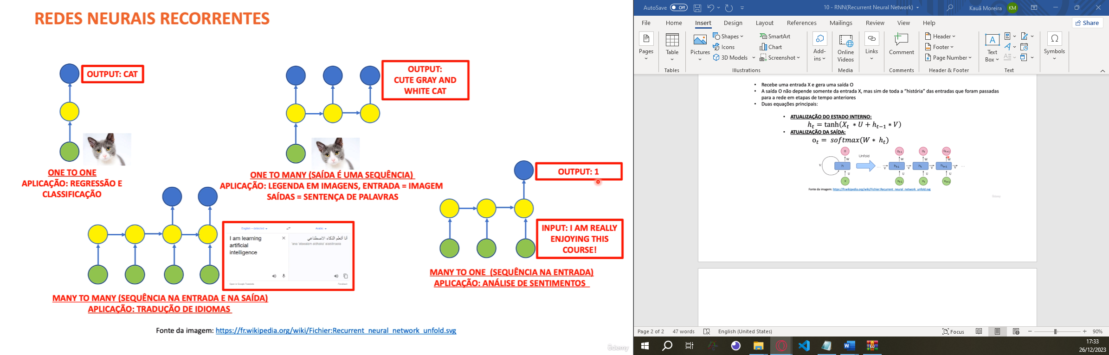

The traditional Recurrent Neural Networks are neural networks that have some limitations about remember long term data! So, to solve this problem, we have the architecture of the traditional RNN(with the limitations) and a other kind of RNN architecture called Long Short-Term Memory(LSTM). Basically, the difference between the RNN and the LSTM is the internal architecture. LSTM can remember long term data while traditional RNN cannot.

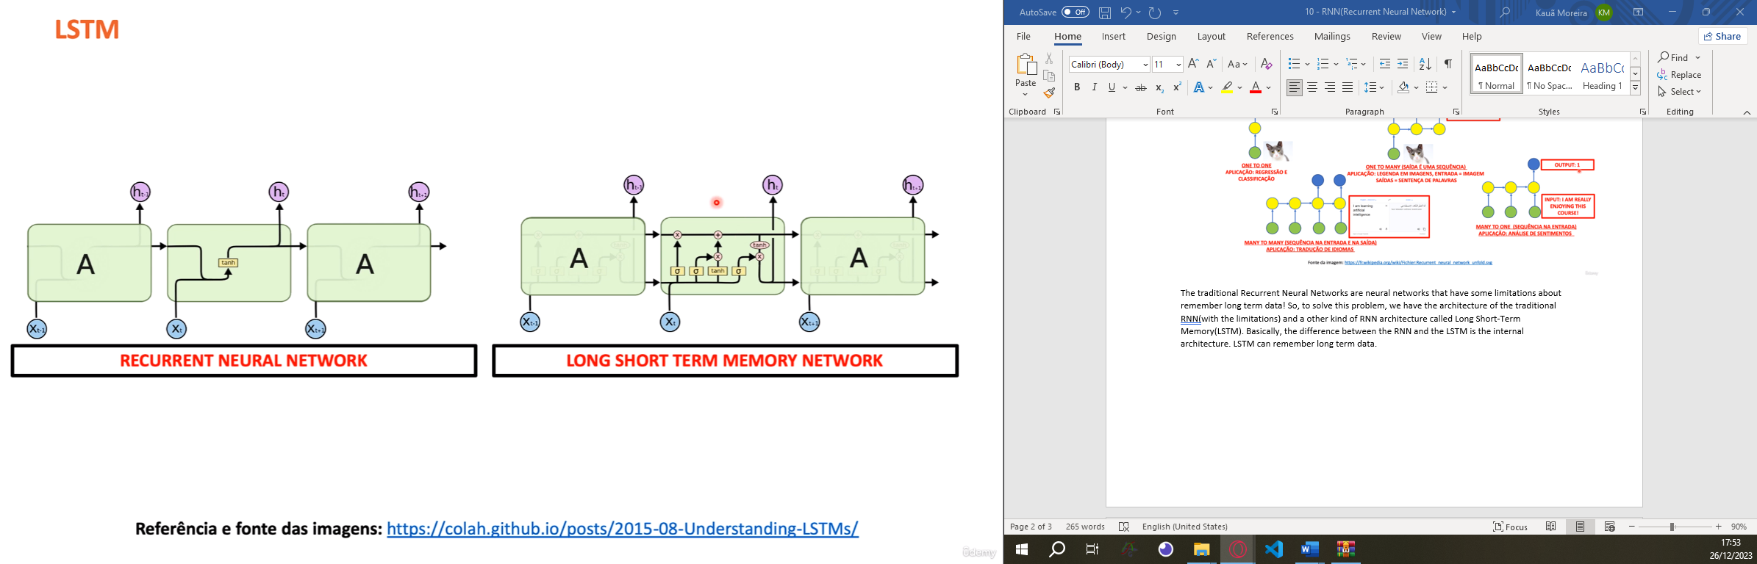

Here we have the math behind the LSTM:

